Hi,
In our design we need another low-level control board, which is supposed to have mainly Teensy 4.1 and motor drivers’ controls.

1. Core Architecture & Power
- Microcontroller: The board shall utilize a Teensy 4.1 as the primary controller.
- Power Input: The system shall be powered by a 5V DC input from an external Power Distribution Board (PDB).
- Voltage Regulation: The board shall provide a stable 3.3V output rail for external sensors and peripherals.
- Power Integrity: Decoupling capacitors shall be placed at all IC power pins and across power rails to ensure signal stability and suppress high-frequency noise.

2. Communication & Motor Control
- I2C Bus:
  - Provide headers for up to three (3) I2C interfaces.
  - Each shall include integrated pull-up resistors sized for the target bus speed.
- SPI Bus:
  - Include a dedicated SPI interface with PCB layout considerations for impedance control and trace length matching.
- CAN Bus:
  - Include a CAN interface utilizing the Teensy 4.1 FlexCAN controller (requires an external transceiver).
- Sabertooth Interface:
  - Provide a dedicated Serial communication interface for Sabertooth motor drivers.
- Logic Level Shifting:
  - Please follow the recommended layout from the TI.
  - Implement unidirectional logic level shifter (SN74AHCT125N) to convert 3.3V Teensy logic to 5V for:
    - Digital LED control signals.
    - Sabertooth motor driver logic (where required).

3. Specialized Actuator & Sensor I/O
- Deposition Motor Encoders:
  - Provide a 6-pin interface for motor encoders. This interface shall operate on 3.3V logic as per validated testing.
- Linear Actuators: Support two (2) linear actuators via two 3-pin interfaces.
  - Feedback: The system shall utilize analog input for position feedback from the actuators.
- Analog Inputs: Provide at least five (5) analog input pins (including actuator feedback).
- Signal Conditioning: Implement Op-Amp voltage buffers for high-impedance inputs (e.g., voltage dividers).
  - Note: Active RC filtering is excluded; local decoupling for the Op-Amp IC is mandatory.
- PWM & Interrupt: Include at least one (1) dedicated PWM interface.
  - Reserve a minimum of two (2) interrupt-capable digital pins for E-Stop relay control or limit switches.
- LED lights: Add a capacitor and a resistor to prevent signal reflection on the data signal pin.

4. Physical & PCB Design Requirements
- Connectors: All off-board connections shall utilize JST 2.54mm (0.1") connectors for secure, standardized interlocking.
- PCB Stackup: Top Layer: Primary signal routing and component placement.
  - Bottom Layer: Dedicated Ground Plane to minimize EMI and provide a low-impedance return path.
- Trace Geometry: Trace widths shall be calculated using the IPC-2221 standard to ensure manufacturing reliability and mechanical durability, regardless of current load.

Do we need Op amp before the ADC?
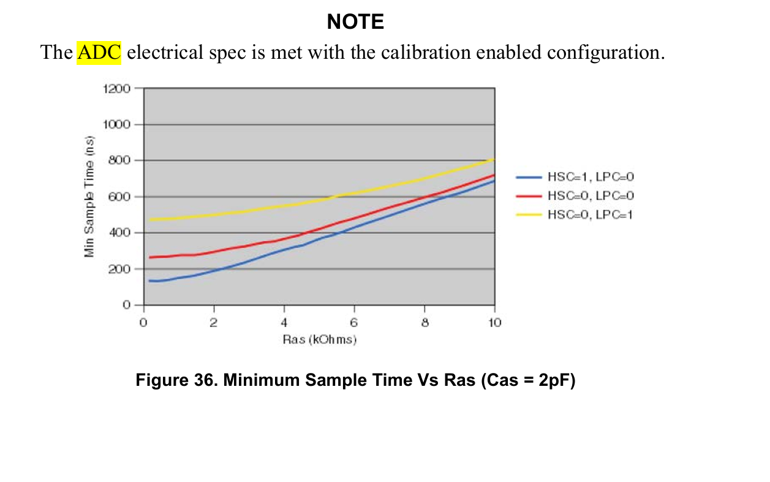
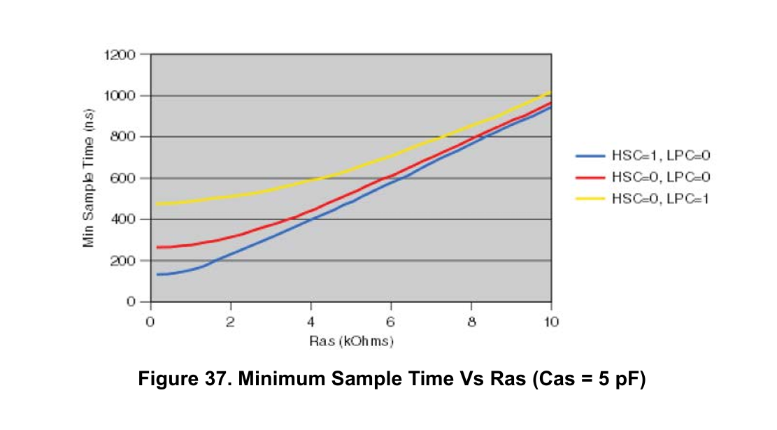
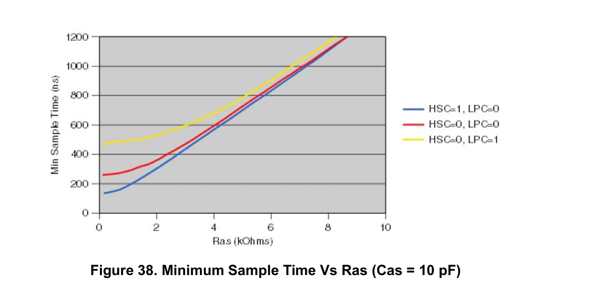
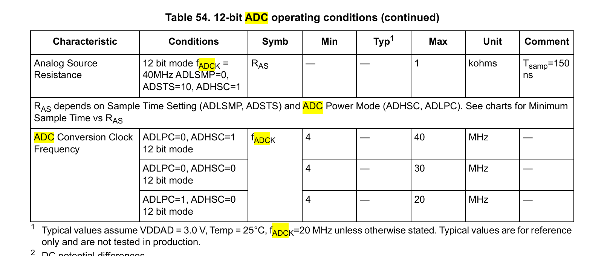

First of all, there are no pull up resistors on the evaluation board. What about the internal pull up resistors?
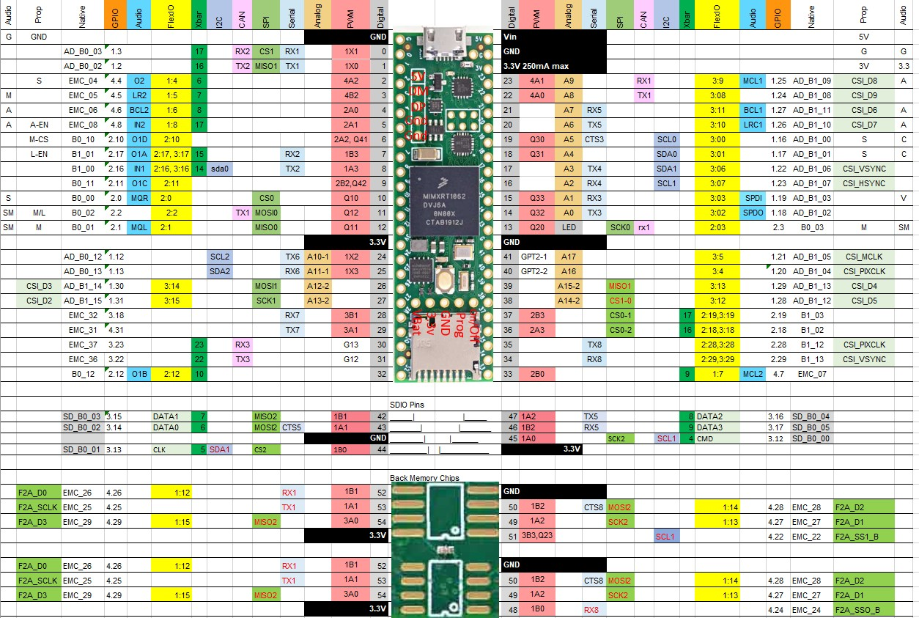
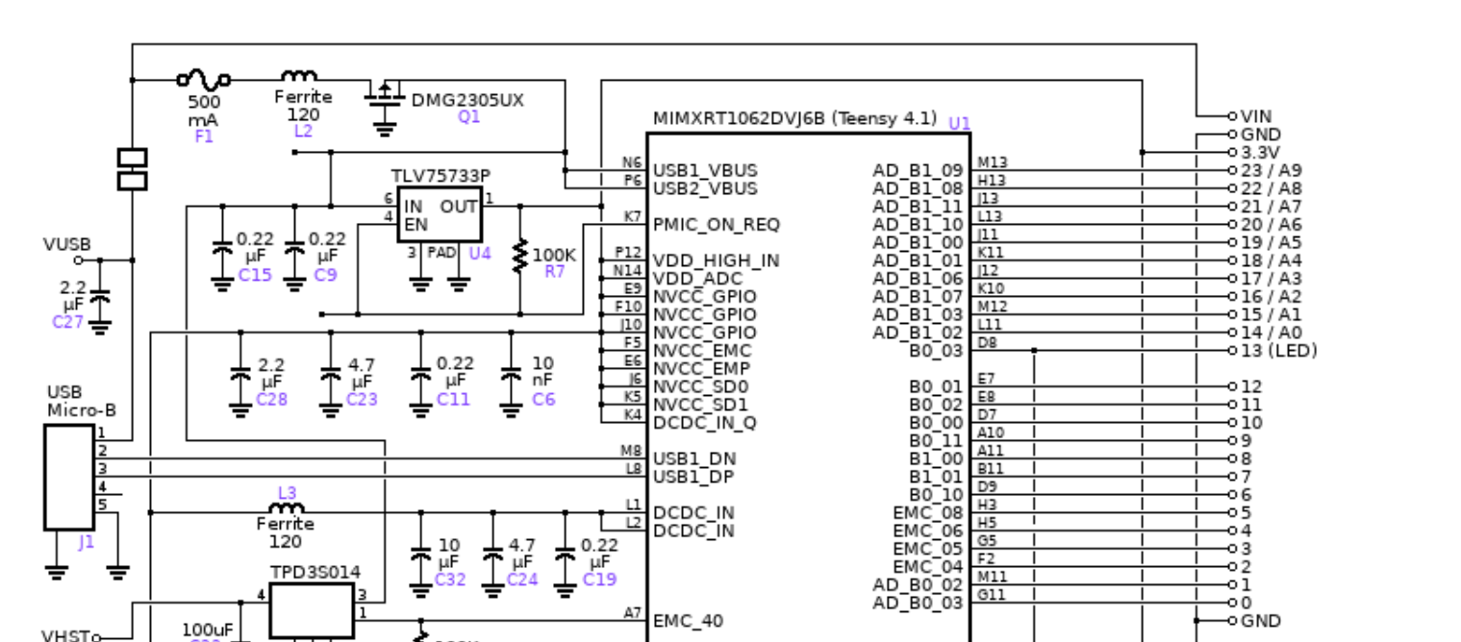
Teensy and Teensy++ Schematic Diagrams

